Big mountain resort report

**Problem Introduction**

Big Mountain Resort recently has installed an additional chair lift to help increase the distribution of visitors across the mountain. But this increases the operating costs by $1,540,000 this season. This business profit margin is 9.2% and the investors would like to keep it there. To recoup the increased operating costs from the new chair, we analysed the data of 330 resort with similar market. We found out that increasing the ticket price of adult weekend could solve this problem.

**Dataset**

We were given a single CSV file from the database manager. The file contains information from 330 resorts in the US that can be considered part of the same market share and we have these same data columns for Big Mountain Resort as well.

**Features and Processing**

First, we reviewed the data information to fill up the missing and NA values. We build summary table and histogram of each numeric features to indicate that they are duplicates or highly correlated features. We also removed outliers by reviewing boxplots. We used pairplots to explore the data relationships and pearson correlation heatmap to identify features that suffer from multi-collinearity. Then we used the sklearn library to build three different models and review the explained variance and mean absolute error to choose a better model. In the end, we chose the best model for demonstrating insights to Big Mountain management. Also, we used the clusters we added to our data frame to create scatter plots for visualizing the Adult Weekend values compared to other characteristics.

**Results and Discussion**

The three models we built all have good R-squared (Explained Variance showed in table 1) around 0.9. We choose model 3 to do the further analysis because the model 3 dropped more unchangeable features to provide more proving insights. We predict the ticket price of adult weekend is $89 from model 3. We also reviewed the results with scatter plots showed below. They all showed the good relationship between the ticket price and other characteristics like skiable terrain and vertical drop.

Table 1: model performances

|  |  |  |  |
| --- | --- | --- | --- |
| **Model** | **Explained Variance** | **Mean Absolute Error** | **Features Dropped** |
| Model 1. | 0.9347 | 5.07 | - |
| Model 2. | 0.9243 | 5.50 | 'state' |
| Model 3. | 0.9257 | 5.46 | 'state','summit_elev','base_elev' |

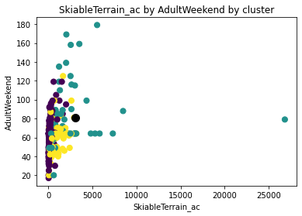

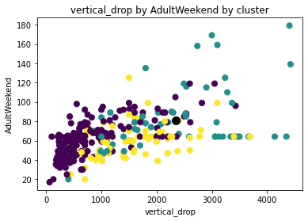

**Conclusion**

The predicted price is $8 more than the price of last season. This should allow Big Mountain Resort to recoup the increased operating costs. Future, we could investigate other features like ticket price of adult weekday and the number of days the resort will be open each season.